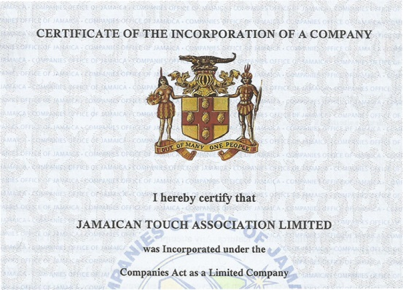**The Companies Act-Jamaica 2004**

**Code of Conduct for Jamaican Touch Association Limited**

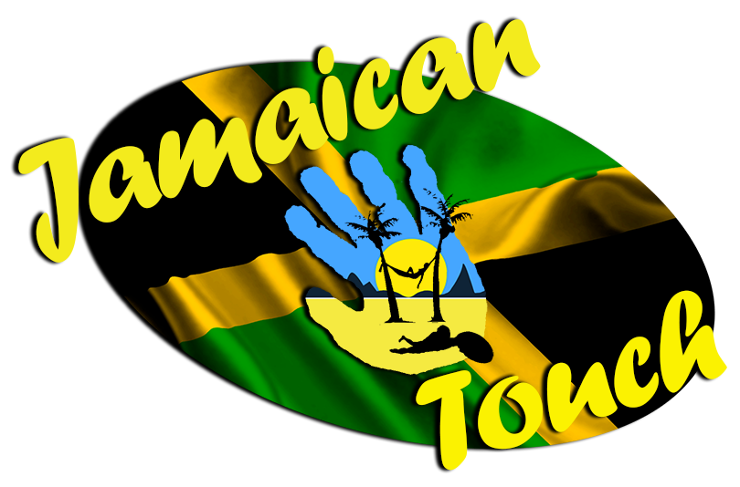

**Jamaican Touch Association**

**Code of Conduct**

Drafted by: Tonka Selby

**Document Version Control**

|  |  |  |  |
| --- | --- | --- | --- |
| **Issue** | **Author** | **Date** | **Amendment** |
| Draft v0.1 | Tonka Selby | 04/06/2016 | Initial document |
| Draft v1.0 | Tonka Selby | 06/06/2016 | Accepted version after review |
| V1.0 | Tonka Selby | 18/06/2016 | Signed off First version after Board approval |
|  |  |  |  |
|  |  |  |  |
|  |  |  |  |
|  |  |  |  |

**Table of Contents**

1. Spectrum 2

2. Purpose 2

3. Expectations 2

4. Disciplinary Process 2

5. Further Information / Contact 3

1. Spectrum

This code applies to all members associated with Jamaican Touch, including;

* All Board and Committee members, whether elected or appointed directly
* All Player level members that have completed and signed the correct application form, and are thus eligible to represent Jamaican Touch
* All Other level members, such as (but not restricted to) Coaching Staff, Selectors, Referees, Medical Staff, Organisers and Assistants, that have completed and signed the correct application form, and are thus eligible to represent Jamaican Touch
* All Organisations, and their members, that enter into Affiliation, Sponsorship or Association agreements with Jamaican Touch

1. Purpose

As representatives of the Jamaican Touch Association, the country of Jamaica, the sport of Touch, and, by extension, FIT and all other Touch organisations, it is our mandate that all members observe the most appropriate level of behaviour and standards at all times.

Outlined below are the expectations, disciplinary process and sources of further information and contact, if required.

1. Expectations

All members and associates of Jamaican Touch are expected to:

* Perform their duties in a professional, respectful, legal, honest and fair manner at all times.
* Be respectful of all people that they come into contact with, regardless of any labels that may have been put on that person, including race, gender, religion, age, ability etc …
* Maintain high levels of dignity and decorum to ensure that Jamaican Touch, and all their associated links, are portrayed in the best light possible.
* Be aware of FIT, and other Touch organisations, and their guidelines and policies to help educate and regulate an internationally acceptable standard.

1. Disciplinary Process

Any persons found to be in breach of these guidelines, or are found to be acting illegally or immorally, or whose actions will in any way damage the reputation of Jamaican Touch, or the sport of Touch in any way, will be investigated by the disciplinary committee as referred to in the Association’s Constitution.

Details will be sent to all Board members, with appropriate actions recommended, that can be agreed with or without a meeting being convened.

Once a decision has been agreed the member facing disciplinary proceedings will be notified in writing and will have 7 days to appeal their case.

Appeals may be initiated in writing or by requesting a meeting with the disciplinary committee which may be refused at the discretion of the said committee.

1. Further Information / Contact

More documentation and contact information can be found on the Jamaican Touch Association web site;

<http://jamaicantouch.com/>

FIT rules, regulations and guidelines can be found on their web site;

<https://www.internationaltouch.org/>

It is advisable to familiarise with similar organisations, such as Touch Australia, New Zealand Touch, England Touch, Touch USA and Ireland Touch Association etc