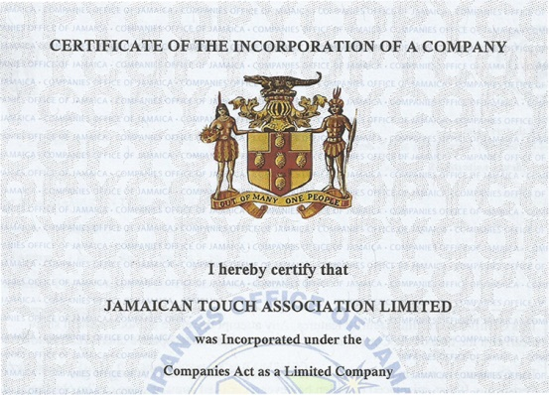**The Companies Act-Jamaica 2004**

**Members Policy for Jamaican Touch Association Limited**

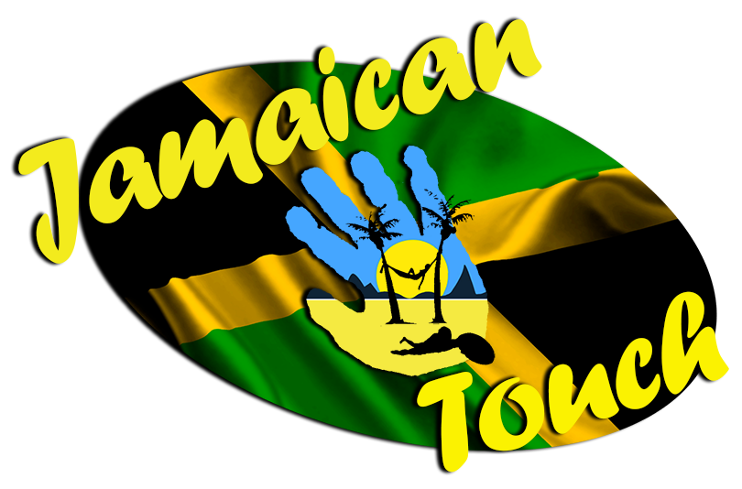

**Jamaican Touch Association**

**Members Policy**

Drafted by: Tonka Selby

**Document Version Control**

|  |  |  |  |
| --- | --- | --- | --- |
| **Issue** | **Author** | **Date** | **Amendment** |
| Draft v0.1 | Tonka Selby | 04/06/2016 | Initial document |
| Draft v1.0 | Tonka Selby | 06/06/2016 | Accepted version after review |
| V1.0 | Tonka Selby | 18/06/2016 | Signed off First version after Board approval |
|  |  |  |  |
|  |  |  |  |
|  |  |  |  |
|  |  |  |  |

**Table of Contents**

1. Scope 2

2. Categories 2

3. Playing level Members 2

4. Non Playing level Members 2

5. Board level Members 2

6. Associate and Affiliate Members 3

7. Expectations 3

8. Application and Acceptance 3

9. Durations and Renewals 3

10. Disciplinary 3

11. Application Forms 4

12. Appendices 5

12.1 Playing Level Member Application Form 5

12.2 Non-Playing Level Member Application Form 6

1. Scope

The purpose of this document is to outline the various forms of Membership agreements that exist, set out the expectations of those agreements and provide the means to apply for and ascertain these Memberships.

More information can be found regarding the policies of Jamaican Touch by either visiting their web site or contacting Board members directly.

1. Categories

Membership of Jamaican Touch Association can be divided into 4 categories that are defined and detailed in later sections:

1. Playing level Members
2. Non Playing level Members
3. Board level Members
4. Associate and Affiliate Members
5. Playing level Members

These are Touch players of all age and gender divisions that are able to compete within the rules, regulations and etiquette of the game, that wish to be considered for inclusion in a Jamaican Touch squad.

1. Non Playing level Members

This includes the people wishing to be involved and assist with the many other aspects of the game for the benefit of Jamaican Touch. These can operate at a local, national or international level as the requirements arise. The roles to be performed include, but not limited to:

* Referees
* Coaching Staff
* Medical Support Personnel
* Team Selectors
* Administration and Support Teams

1. Board level Members

The roles and responsibilities of the Board allocation and make up are outlined in the Constitution. Acceptance of a role on the Board equates to agreement to adhere to all the expectations associated with it.

This includes both Elected and Appointed Board Members.

1. Associate and Affiliate Members

This includes all clubs, companies and other organisations that enter into an agreement with Jamaican Touch Association.

Jamaican Touch provide a guarantee that they will adhere to their own Codes of Conduct and maintain the highest and most professional standards at all times, and expect any organisation that they are connected with to adhere to the same levels.

1. Expectations

It is expected that all members will honour any and all agreements that they enter into in the spirit of the Association and it’s intentions.

All members must familiarise themselves with, and adhere to the Constitution and the Codes of Conduct of Jamaican Touch Association.

All Playing and Non Playing category members also need to familiarise themselves with, adhere to and abide by all the applicable FIT guidelines, such as Anti-Doping Policies, Codes of Conduct, Uniform Policies etc.

Any persons wishing to be associated with, or part of Jamaican Touch Association must have an understanding of both the Association and the sport of Touch to ensure that any actions are in line with the spirit, ethos and aims of the game. Research into FIT, Touch, Rugby and similar associations (such as Touch Australia, New Zealand Touch, Touch USA etc) is highly recommended for the continuation of the integrity of all those involved.

1. Application and Acceptance

All applications and requests for membership consideration must be submitted in writing to a currently serving board member.

On-line forms are available on the web site that can be submitted directly or completed off line.

Non standard agreements are available on request and can be tailored accordingly.

Playing and Non Playing category members require approval from a majority of members to be accepted. Board Members approval is outlined in the Constitution. Association and Affiliate membership agreements must be approved by all board members.

1. Durations and Renewals

Standard membership agreements will run for 12 months after which they can be renewed, renegotiated or can automatically renew.

1. Disciplinary

Any members or agreements that are found to be in breach of the Codes of Conduct, or prove to be detrimental or harmful to the reputations of the Association, FIT or the sport of Touch, will be subject to a disciplinary hearing and could face immediate cancellation.

1. Application Forms

Copies of available forms are here in the Appendices, are available individually for download on the web site, or can also be completed on line at the web site.

Specific or non-standard agreements are available on request, so please contact a serving Board member to commence negotiations.

1. Appendices
   1. Playing Level Member Application Form



* 1. Non-Playing Level Member Application Form





**Or visit** [**http://jamaicantouch.com/**](http://jamaicantouch.com/)